SIMATS ENGINEERING (SAVEETHA SCHOOL OF ENGINEERING)
Department of Computer Science and Engineering
CO1 ASSESSMENT TOOL 1 – Case Study Analysis
Course Code: | CSA10 / CSA1063 | Course Title: | Software Engineering
CO Assessed: | CO1 | Assessment: | Assessment Tool 1 – Case Study Analysis
Weightage: | 20% | Total Marks: | 25
CO1 Statement: | Apply advanced methodologies and agile project management techniques to manage software projects effectively
Student Name: | K.Prathiba | Reg. No.: | 192421163
Date: | 29-07-2026 | Duration: | 60 minutes

Code of Conduct
I ___ K.Prathiba (192421163)____ (Name / Reg No) certify that this submission is my original work and that I have adhered to the guidelines specified for this assessment. I understand that any violation of academic integrity rules will result in disciplinary action.
Signature of the Student: ______ K.Prathiba ___________________

Annexure A – Case Study Analysis

AI-BASED PERSONAL FINANCE AND BUDGET PLANNING SYSTEM (BANKING & FINANCE)

- Understand the Problem Statement
- Explain the problem in your own words.
- Many individuals struggle to manage their income, expenses, savings, investments, and financial goals effectively.
- Traditional budgeting methods such as spreadsheets or manual record keeping are time-consuming and often inaccurate.
- Users may overspend, fail to save regularly, or make poor financial decisions due to a lack of financial awareness and planning.
- Existing finance applications generally provide only transaction tracking and limited personalized guidance.
- The proposed AI-Based Personal Finance and Budget Planning System aims to intelligently analyze users’ financial data
- Its provide personalized budgeting recommendations.
- Artificial Intelligence techniques can be used to predict spending patterns, identify unnecessary expenses, suggest savings opportunities, and help users achieve financial goals.

  - Identify the objectives of the proposed system.
Main Objective
- To develop an intelligent personal finance management system that assists users in budgeting, expense tracking, savings planning, and financial decision-making through Artificial Intelligence.
Specific Objectives
    - To automatically track and categorize user income and expenses.
    - To generate personalized budget plans based on spending habits.
    - To predict future expenses using AI-based analysis.
    - To provide recommendations for savings and investments.
    - To help users achieve short-term and long-term financial goals.
    - To identify unnecessary expenditures and spending risks.
    - To generate alerts for overspending and bill payments.
    - To provide visual reports and financial insights.
    - To improve financial discipline and money management.
    - To support informed financial decision-making.
  - State the scope of the problem.
- The system focuses on personal finance management, budgeting, expense tracking, and financial planning.
- It can be used by students, employees, freelancers, business owners, and families.
- The system analyzes financial transactions, spending habits, savings patterns, and financial goals.
- It provides AI-driven recommendations for budget allocation and expense optimization.
- The system can be integrated with banking applications and digital payment platforms.
- Overall, the proposed system aims to improve financial awareness, budgeting efficiency, and long-term financial stability.
- Identify Key Stakeholders and Challenges
  - Identify all the stakeholders involved in the system.
- Individual users
- Financial advisors
- Banking institutions
- System administrators
- Software developers
- AI and Data Science engineers
- Customer support teams
- Financial regulatory authorities
- Database administrators
- Third-party payment service providers

  - Explain the roles and responsibilities of each stakeholder.
- Users enter financial information, track expenses, and utilize recommendations provided by the system.
- Financial advisors provide guidance and validate financial planning strategies.
- Banking institutions provide transaction information and secure financial integration.
- System administrators manage user accounts, permissions, and system operations.
- Software developers design, implement, test, and maintain the application.
- AI engineers develop and improve predictive budgeting and recommendation algorithms.
- Customer support teams assist users with technical and operational issues.
- Regulatory authorities ensure compliance with banking and financial regulations.
- Database administrators manage data storage, backup, and security.
- Payment service providers support transaction synchronization and digital payment integration.
  - Discuss the major challenges and issues faced by the stakeholders.
- Users may not consistently record financial information.
- Protecting sensitive financial data is a major challenge.
- Banks require secure integration and regulatory compliance.
- Developers must continuously improve AI models and budgeting accuracy.
- AI engineers require high-quality financial datasets for training models.
- Regulatory bodies must ensure privacy and security standards are followed.
- Database administrators must prevent unauthorized access and data breaches.
- Financial predictions may sometimes be inaccurate due to changing economic conditions.
- Analyze the Current Approach
  - Describe the existing system or current process.
- Most individuals use notebooks, spreadsheets, mobile calculators, or basic finance applications to track expenses.
- Traditional budgeting requires manual entry of transactions and financial calculations.
- Some banking applications provide transaction history but offer limited financial planning support.
- Existing systems generally lack intelligent forecasting and personalized financial recommendations.
- Users often analyze their finances manually, which can lead to errors and poor budgeting decisions.

  - Identify its strengths and limitations.
Strengths
- Simple and easy to understand.
- Available through spreadsheets and banking applications.
- Helps users maintain basic records of income and expenses.
- Provides transaction history and expenditure tracking.
Limitations
      - Requires manual effort and regular updates.
      - Limited prediction and financial planning capabilities.
      - No intelligent spending analysis.
      - Cannot effectively identify future financial risks.
      - Lack of personalized recommendations.
      - Difficult to monitor long-term financial goals.
  - Analyze the problems or gaps that need to be addressed.
- Lack of automated budgeting support.
- No intelligent expense prediction.
- Limited financial goal tracking.
- Inadequate spending behavior analysis.
- Difficulty in identifying unnecessary expenditures.
- Absence of AI-driven financial recommendations.
- Limited visualization and financial insights.
- Insufficient support for long-term financial planning.
- Propose a Suitable Solution Using Software Engineering Principles
- Design a software-based solution for the given problem.
- The proposed AI-Based Personal Finance and Budget Planning System provides intelligent financial management services by collecting and analyzing user financial data. The system automatically categorizes transactions, predicts future spending, recommends budgets, tracks savings goals, and generates financial reports.
- Artificial Intelligence techniques analyze spending behavior and provide personalized recommendations that help users improve financial stability and achieve their goals.

  - Describe the major functional modules of the proposed system.

Module 1: User Registration and Profile Management
- Functions:
  - User registration
  - Secure login
  - Profile management
  - Goal configuration

Module 2: Financial Data Collection Module
- Functions:
  - Income recording
  - Expense recording
  - Transaction synchronization
  - Bank account integration

Module 3: Expense Categorization Module
- Functions:
  - Automatic transaction categorization
  - Expense classification
  - Spending trend analysis

Module 4: Budget Planning Module
- Functions:
  - Budget creation
  - Budget recommendations
  - Monthly budget allocation
  - Goal-based planning

Module 5: AI Prediction and Recommendation Module
- Functions:
  - Expense forecasting
  - Savings prediction
  - Investment suggestions
  - Personalized financial recommendations

Module 6: Alert and Notification Module
- Functions:
  - Overspending alerts
  - Bill payment reminders
  - Savings goal notifications
  - Budget warnings

Module 7: Reporting and Analytics Module
- Functions:
  - Financial dashboards
  - Spending reports
  - Savings reports
  - Trend visualization

Module 8: Security and Access Management Module
- Functions:
  - Authentication
  - Authorization
  - Data encryption
  - User access control
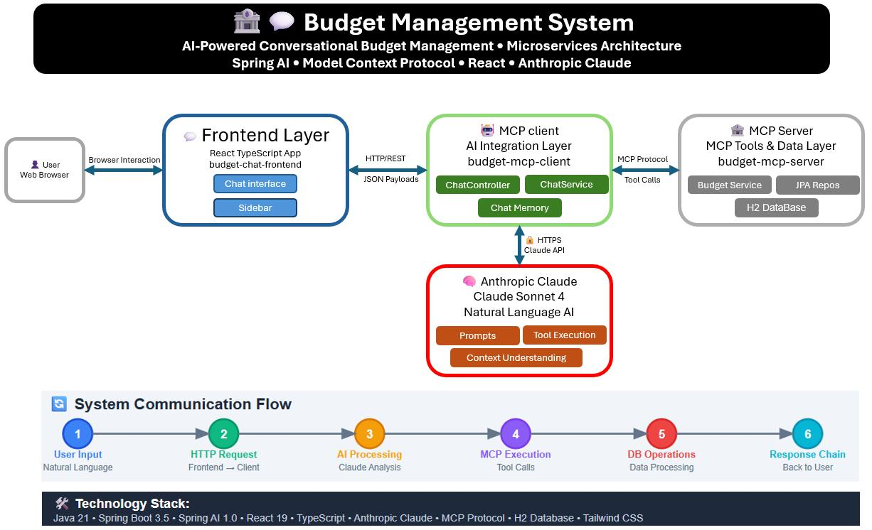
Figure 4.1
- Illustrates the overall architecture of the AI-Based Personal Finance and Budget Planning System.
- Users interact through the front-end interface to manage financial information.
- The AI integration layer processes financial data, predicts spending patterns,
generates budget recommendations, and communicates with the database layer.
- The reporting, notification, and security modules ensure effective financial
management, data protection, and user-friendly financial insights.
- Identify the functional and non-functional requirements.
Functional Requirements
- User registration
- Income tracking
- Expense tracking
- Budget creation
- Expense categorization
- Financial forecasting
- Savings tracking
- Alert generation
- Financial reporting
- Recommendation generation
- Goal management
- Bank account integration
Non-Functional Requirements
- Security
- Reliability
- Performance
- Scalability
- Maintainability
- Availability
- Usability
- Compatibility
- Data Privacy
- Accuracy
- Fast response time
- Data Integrity
- Flexibility
  - Explain how software engineering principles such as modularity, scalability, maintainability, reliability, usability, and security are incorporated into your solution.
- Modularity – Separate modules handle budgeting, prediction, reporting, security, and recommendations.
- Scalability – The system supports growing numbers of users and transactions.
- Maintainability – New features and AI models can be updated independently.
- Reliability – Accurate and consistent financial analysis is provided.
- Usability – A simple dashboard enables easy financial management.
- Security – Financial information is protected using encryption and authentication mechanisms.
- Performance – Financial calculations and recommendations are generated quickly.
- Flexibility – Additional financial services can be integrated easily.
- Testability – Each module can be independently tested and validated.
- Data Integrity – Financial records remain accurate and protected from unauthorized modification.
- Justify the Chosen Methodology/Framework
- Select an appropriate Software Development Life Cycle (SDLC) model or software development framework (e.g., Agile, Scrum, Waterfall, Spiral, DevOps).
- The Agile Software Development Model is selected for developing the AI-Based Personal Finance and Budget Planning System.
- Agile supports iterative development and continuous improvement, making it suitable for applications that require regular feature updates and user feedback.
- The system can be developed in multiple sprints focusing on budgeting, forecasting, recommendation engines, reporting, and security modules.
  - Justify why the selected methodology/framework is suitable for the proposed system.
    - Agile supports continuous enhancement of AI algorithms.
    - Financial requirements can change frequently.
    - User feedback can be incorporated quickly.
    - Features can be delivered incrementally.
    - Testing can be performed during every sprint.
    - Risks can be identified early.
- System performance can be continuously improved.
- Security features can be updated regularly.
- Budgeting and recommendation modules can evolve based on user needs.
- Agile improves collaboration among stakeholders.
  - Explain how it supports successful project development and maintenance.
- Agile divides the project into manageable iterations. Each sprint focuses on developing and testing specific modules. Continuous testing helps identify defects early. Regular user feedback improves system usability and performance. Financial regulations and user requirements can be accommodated easily.
- AI models can be retrained and improved continuously. Maintenance activities such as bug fixing, security updates, and feature enhancements can be performed efficiently throughout the software lifecycle.
- Discuss Expected Outcomes and Limitations
- The proposed AI-Based Personal Finance and Budget Planning System helps users manage their finances efficiently through intelligent budgeting and expense tracking.
- It provides personalized recommendations, spending analysis, and financial forecasting to improve decision-making. The system reduces manual effort through automated expense categorization and alerts.
- However, challenges such as data privacy, banking integration, and prediction accuracy may affect performance. Future enhancements like investment advisory services, fraud detection, and mobile integration can further improve the system.
  - Describe the expected benefits of the proposed solution.
- Improved personal financial management.
- Better budgeting and spending control.
- Increased savings opportunities.
- Intelligent financial recommendations.
- Faster financial decision-making.
- Better financial goal achievement.
- Improved financial awareness.
- Reduced unnecessary expenditures.
- Enhanced financial planning accuracy.
- Better long-term financial stability.
  - Explain how the solution addresses the identified challenges.
- AI-based forecasting predicts future expenses accurately.
- Automated categorization reduces manual effort.
- Personalized recommendations improve budgeting efficiency.
- Financial alerts help prevent overspending.
- Visual reports improve financial understanding.
- Goal tracking encourages disciplined saving behavior.
- Secure architecture protects sensitive financial information.
- Continuous learning improves recommendation accuracy.
  - Discuss potential risks, implementation challenges, and limitations.
- AI predictions may not always be completely accurate.
- Users may provide incomplete financial information.
- Integration with banking systems may be complex.
- Data privacy and security concerns must be addressed.
- Financial regulations may vary across regions.
- High-quality datasets are required for AI training.
- System maintenance and model retraining require resources.
- Unexpected economic conditions can affect prediction accuracy.
- Suggest possible future enhancements.
- Integration with multiple banking platforms.
- Advanced investment advisory features.
- Real-time financial market analysis.
- Voice-based financial assistants.
- Mobile application integration.
- AI-powered debt management recommendations.
- Fraud detection capabilities.
- Personalized retirement planning features.
- Cloud-based scalability and analytics.
- Advanced deep learning models for financial forecasting.

Rubrics for Calculation
Criteria | Excellent (5 Marks) | Good (3 Marks) | Satisfactory (2 Marks) | Needs Improvement (1 Mark)
Problem Understanding | Clearly explains the problem, objectives, and scope with complete understanding. | Explains the problem with minor omissions. | Basic understanding with limited explanation. | Poor understanding; objectives and scope are unclear or missing.
Stakeholder & Challenge Analysis | Identifies all stakeholders, their roles, and challenges with clear analysis. | Identifies most stakeholders and challenges with adequate analysis. | Identifies only a few stakeholders or challenges. | Stakeholders and system analysis are incomplete or inaccurate.
Current System Analysis | Thoroughly analyzes the existing system, strengths, weaknesses, and identifies all gaps. | Good analysis with most strengths and weaknesses identified. | Limited analysis with partial identification of issues. | Proposed solution is unclear or inappropriate; requirements are largely missing.
Proposed Software Solution & Software Engineering Principles | Proposes an innovative, feasible solution applying appropriate software engineering principles (modularity, scalability, maintainability, security, etc.). | Suitable solution with good application of software engineering principles. | Basic solution with limited application of software engineering principles. | Methodology is inappropriate, poorly justified, or not discussed.
Methodology/ Framework Justification | Selects the most suitable SDLC/model/framework and provides strong technical justification. | Suitable methodology selected with adequate justification. | Methodology selected but justification is weak. | Outcomes, limitations, or future enhancements are missing; report lacks organization and clarity.

Criteria | Mark
Problem Understanding | /5
Stakeholder & Challenge Analysis | /5
Current System Analysis | /5
Proposed Software Solution & Software Engineering Principles | /5
Methodology/ Framework Justification | /5
TOTAL | /5

